**TUGAS 08**

**PRAK09 Task App**



Praktikum Pemrograman Berbasis Web - A

Nama :

Adelia Nurlina Putri 4521210059

**PROGRAM STUDI S1 TEKNIK INFORMATIKA**

**FAKULTAS TEKNIK**

**UNIVERSITAS PANCASILA**

**JAKARTA**

**2024**

1. **Project prak08**
   1. **First Initialization**
2. Akses web <https://docs.flutter.dev/ui/layout/tutorial>
3. Buka Android Studio

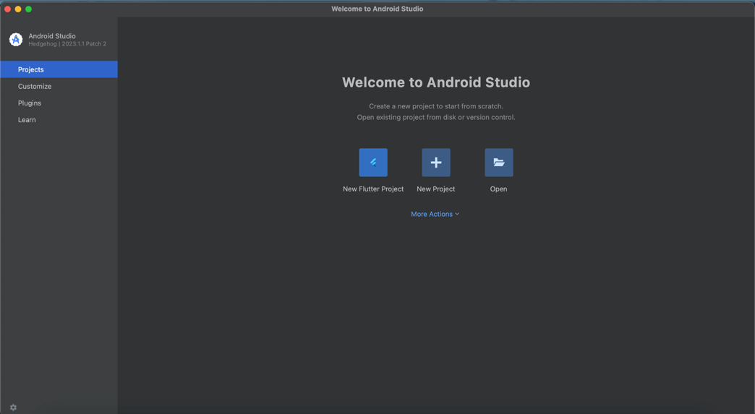

1. Pilih New Flutter Project -> Flutter -> Next

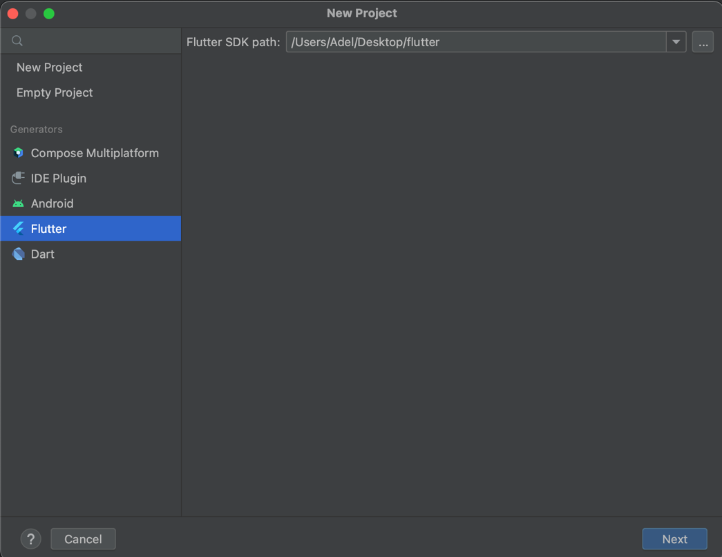

1. Isi form untuk nama project, tempat project, type, bahasa pemrograman, platforms dan lainnya -> Create

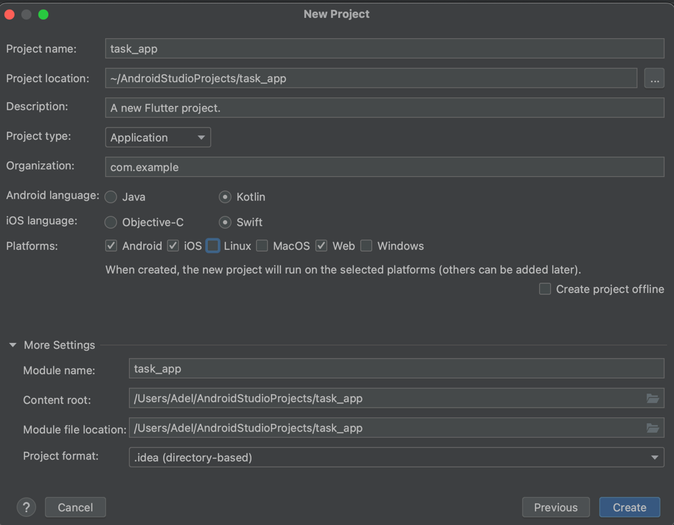

* 1. **Membuat Ap**

1. Add Package Provider

|  |
| --- |
| $ flutter pub add provider |

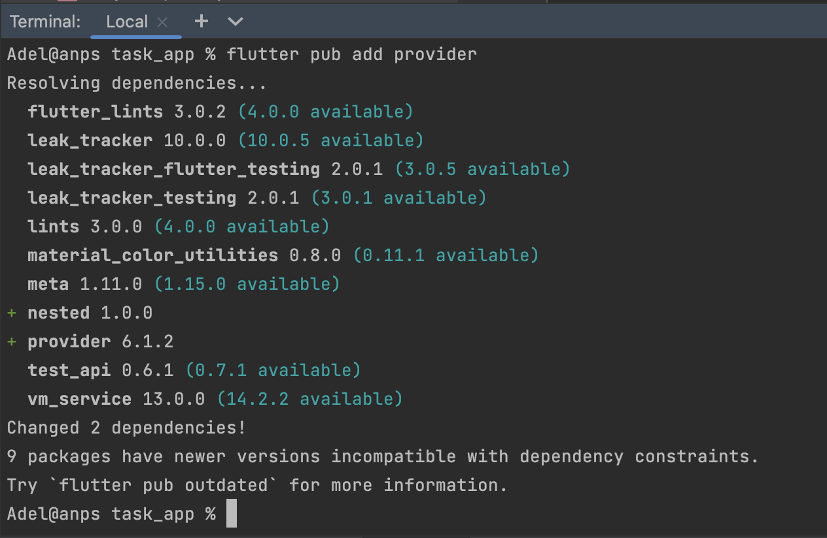

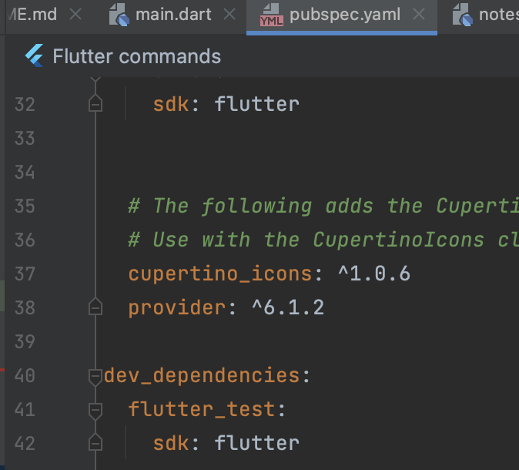

1. Membuat folder models untuk memasukan kela Note dan NotesOperation yang berfungsi untuk membuat String dan membuat obiect note serta list note
2. Membuat folder screen untuk membuat tampilan notes dan tampilan notes ketika akan menambahkan note atau task baru.

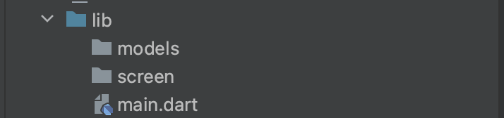

1. File file notes_operation.dart dan note.dart pada folder models

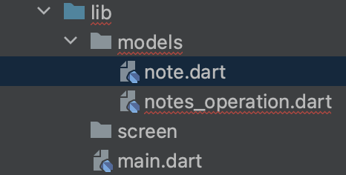

1. File notes_operation.dart

|  |
| --- |
| import 'package:flutter/cupertino.dart'; import 'package:task_app/models/note.dart'; class NotesOperation with ChangeNotifier { //List of note  List<Note> _notes = [];  List<Note> get getNotes {  return _notes;  }  NotesOperation() {  addNewNote('First Note', 'First Note Description');  }  void addNewNote(String title, String description) {  Note note = Note(title, description);  _notes.add(note);  notifyListeners();  }  } |

1. File note.dart

|  |
| --- |
| class Note {  String title;  String description;   Note(this.title, this.description); } |

1. Membuat file home_screen.dart dan add_screen.dart
2. File home_screen.dart

|  |
| --- |
| import 'package:flutter/material.dart'; import 'package:provider/provider.dart'; import 'package:task_app/models/note.dart'; import 'package:task_app/models/notes_operation.dart'; import 'package:task_app/screen/add_screen.dart';  class HomeScreen extends StatelessWidget {  @override  Widget build(BuildContext context) {  return Scaffold(  backgroundColor: Colors.*blueGrey*,  floatingActionButton: FloatingActionButton(  onPressed: () {  Navigator.*push*(  context,  MaterialPageRoute(  builder: (context) => AddScreen(),  ),  );  },  child: Icon(Icons.*add*, size: 30, color: Colors.*blueGrey*),  backgroundColor: Colors.*white*,  ),  appBar: AppBar(  title: Text(  'Task Manager',  style: TextStyle(  fontSize: 25,  fontWeight: FontWeight.*bold*,  ),  ),  centerTitle: true,  elevation: 0,  backgroundColor: Colors.*transparent*,  ),  body: Consumer<NotesOperation>(  builder: (context, NotesOperation data, child) {  return ListView.builder(  itemCount: data.getNotes.length,  itemBuilder: (context, index) {  return NotesCard(data.getNotes[index]);  },  );  },  ),  );  } }  class NotesCard extends StatelessWidget {  final Note note;   NotesCard(this.note);   @override  Widget build(BuildContext context) {  return Container(  margin: EdgeInsets.all(15),  padding: EdgeInsets.all(15),  height: 150,  decoration: BoxDecoration(  color: Colors.*white*,  borderRadius: BorderRadius.circular(15),  ),  child: Column(  crossAxisAlignment: CrossAxisAlignment.start,  children: [  Text(  note.title,  style: TextStyle(fontSize: 20, fontWeight: FontWeight.*bold*),  ),  SizedBox(height: 5),  Text(  note.description,  style: TextStyle(fontSize: 17),  ),  ],  ),  );  } } |

1. File add_screen.dart

|  |
| --- |
| import 'package:flutter/material.dart'; import 'package:provider/provider.dart'; import 'package:task_app/models/notes_operation.dart';  class AddScreen extends StatelessWidget {  @override  Widget build(BuildContext context) {  String titleText = '';  String descriptionText = '';   return Scaffold (  backgroundColor: Colors.*blueGrey*,  appBar: AppBar (  title: Text('Task Manager'),  centerTitle: true,  elevation: 0,  backgroundColor: Colors.*transparent*,  ),  body: Padding (  padding: EdgeInsets.only(  top: 15,  left: 15,  right: 15,  bottom: 80,  ),  child: Column (  children: [  TextField(  decoration: InputDecoration(  border: InputBorder.*none*,  hintText: 'Title',  hintStyle: TextStyle(  fontSize: 20,  fontWeight: FontWeight.*bold*,  color: Colors.*white*,  ),  ),  style: TextStyle(  fontSize: 20,  fontWeight: FontWeight.*bold*,  color: Colors.*white*,  ),  onChanged: (value) {  titleText = value;  },  ),  Expanded (  child: TextField(  decoration: InputDecoration(  border: InputBorder.*none*,  hintText: 'Enter Description',  hintStyle: TextStyle (  fontSize: 18,  color: Colors.*white*,  ),  ),  style: TextStyle(  fontSize: 18,  color: Colors.*white*,  ),  onChanged: (value) {  descriptionText = value;  },  ),  ),  TextButton (  onPressed: () {  Provider.*of*<NotesOperation>(context, listen: false)  .addNewNote(titleText, descriptionText);  Navigator.*pop*(context);  },  style: TextButton.*styleFrom*(  padding:  EdgeInsets.only(left: 30, right: 30, top: 10, bottom: 10),  backgroundColor: Colors.*white*,  ),  child: Text ('Add Note',  style: TextStyle(  fontSize: 20,  fontWeight: FontWeight.*bold*,  color: Colors.*blueGrey*,  )),  )  ],  ),  ),  );  } } |

1. File main.dart

|  |
| --- |
| import 'package:flutter/material.dart'; import 'package:provider/provider.dart'; import 'package:task_app/models/notes_operation.dart'; import 'package:task_app/screen/home_screen.dart';  void main () => runApp(MyApp ());  class MyApp extends StatelessWidget {  @override  Widget build(BuildContext context) {  return ChangeNotifierProvider<NotesOperation>(  create: (context) => NotesOperation(),  child: MaterialApp(  debugShowCheckedModeBanner: false,  home: HomeScreen(),  ),  );  } } |

Kode di atas akan membuat aplikasi Flutter dengan state management provider untuk mengelola tugas aplikasi

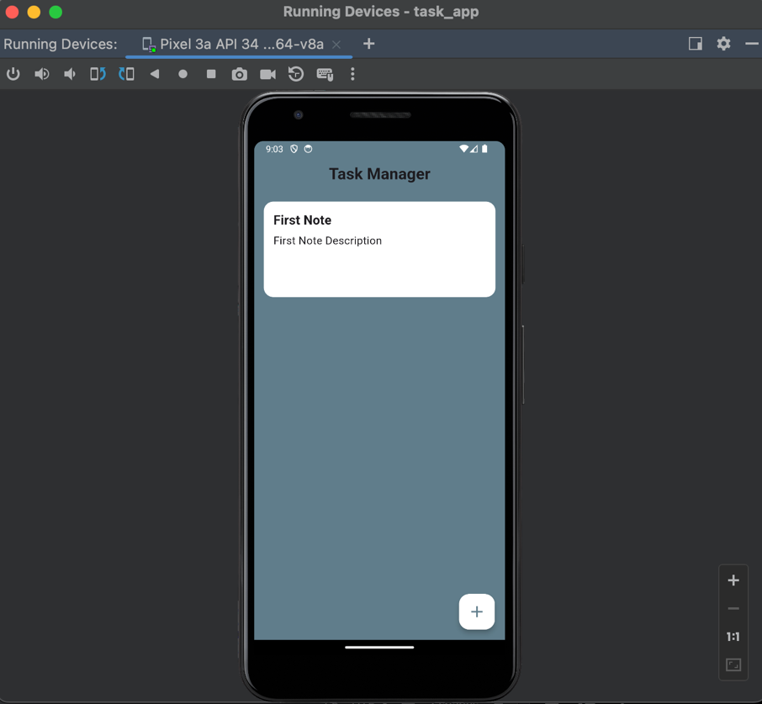 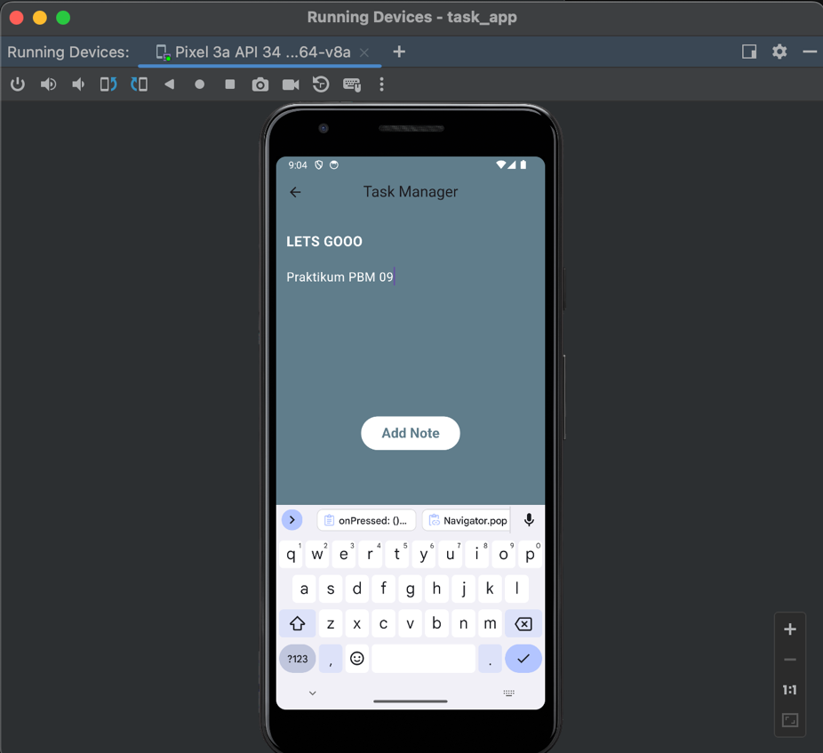 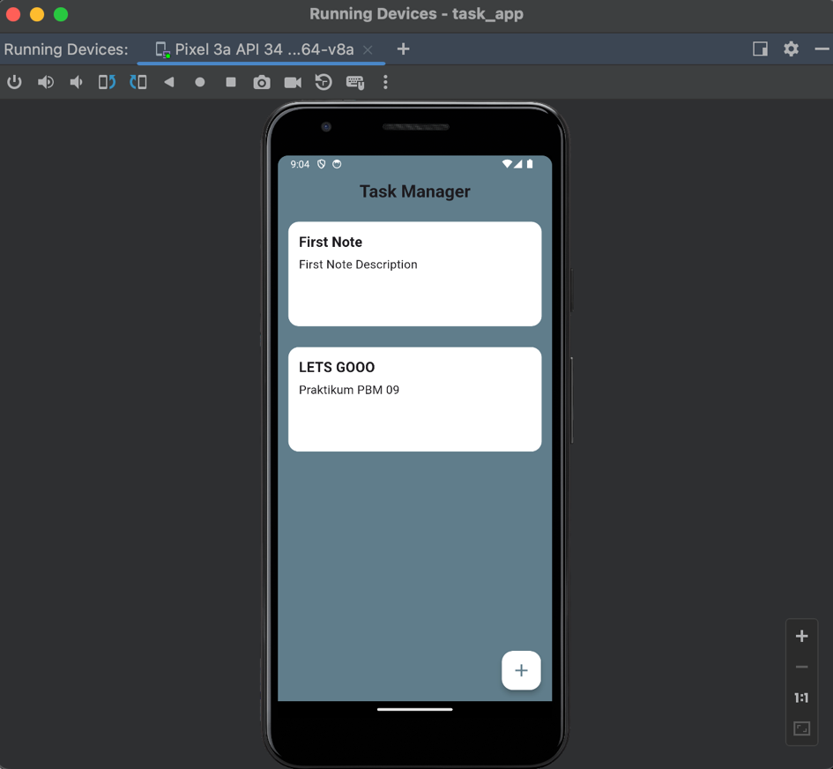

* 1. **Push Code to GitHub** <https://github.com/adelianurlinap/Prak_PBM.git>
     1. Clone Repository yang telah dibuat :

|  |
| --- |
| git clone https://github.com/adelianurlinap/Prak_PBM.git |

* + 1. Add dan commit

|  |
| --- |
| git add .  git commit -m "Tugas8" |

* + 1. Push code

|  |
| --- |
| git push |

1. **Kesimpulan**

Pada tugas 8 ini, telah dilakukan praktek untuk membuat aplikasi dengan state management provider

1. **Referensi**

modul prak09